Now, we will learn about stocks. Notice that even if you don't intend on buying stocks directly, for example, even if you intend on investing through a mutual fund, you still need to understand what a stock is because there are different types of stocks, and when you're investing in a fund, you need to understand, what this fund's objective is. Different funds have different objectives. They have a prospectus (financial document) that you can read that will tell you what this fund is going to do. If you don't understand what the underlying securities that this fund is going to be holding are, then you're not going to understand what this fund is going to be doing. So, even if you want to have your money managed by a professional, you still need to understand what are these things that are in this portfolio because, again, when you see a professional, like an investment adviser that tells you “you should buy this portfolio, this fund or that fund”, each fund is different and is going to perform differently. One fund might not be as good as another fund for you. So, it's very important to understand the underlying assets, even if you do not intend on purchasing them directly.

Private Companies and Stocks
- Assume you are good at manufacturing and assembling electric bikes. So, you started your home business for electric bikes. That is, you build electric bikes at your home garage and just sell it for your friends and the people who know you. At some point, you can’t just keep doing this, you can’t keep selling electric bikes under your name, you have to start a private company so that you sell these bikes under the company’s name. You are now 100% owner of your company. Assume you earn $100,000 per year from this company. At some point, the demand on your electric bikes became much bigger and you cannot handle it, you need to build a large store for your company where you sell your bikes. However, assume building the store, buying equipment, hiring employees, etc. would cost you $2,000,000! This means you will wait for 20 years to build your store, which is unacceptable. So, what can you do in this situation? You can sell a part of the company for an investor! That is, you tell an investor “Hey, invest $2,000,000 in my company, and you will own 50% of the company”. Now, you take the $2,000,000 from the investor, build your store, and expand your profits. But now, the investor owns 50% of the profits you make. So, assume the company’s annual profit increased from $100,000 to $1,000,000 after building the store. The investor takes $500,000 of them, and you get $500,000. So, you raised your profit from $100,000 to $500,000 and you didn’t even pay for building the store, the investor did it all! This is why companies sell shares; they sell shares because they need fund. Selling shares makes their company grow quicker. Some people insist on owning 100% of their company, but their company never grows. A popular quote says “owning 100% of nothing is a lot less than owning 17% of a big company. Check this nice picture below.
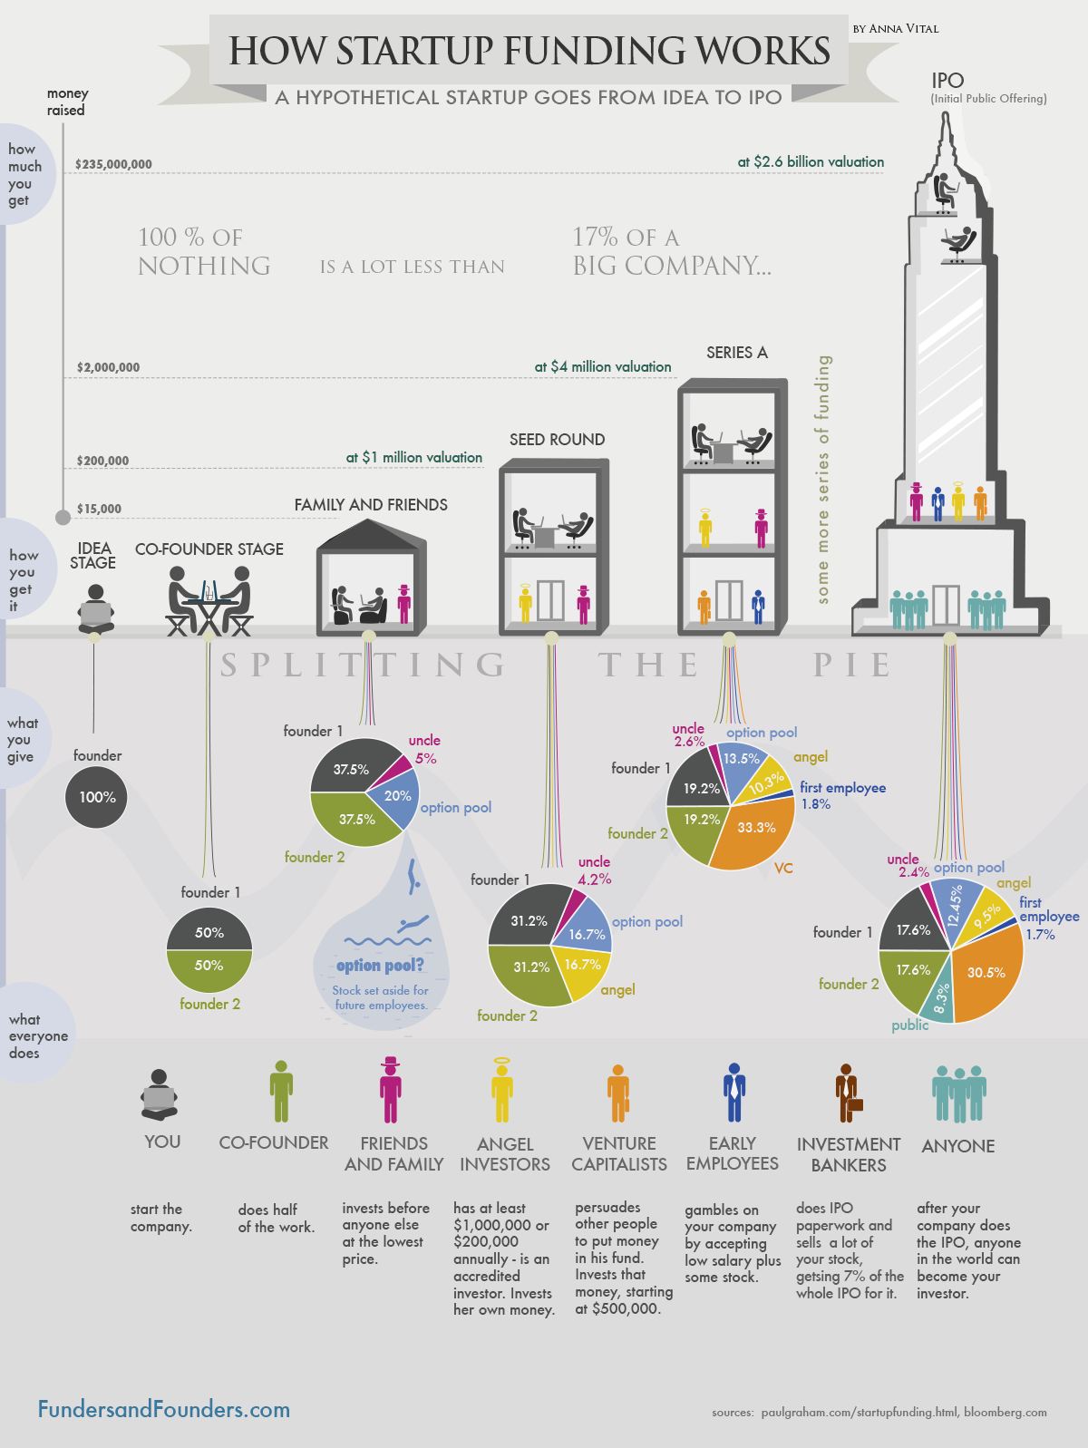
So, who can this investor be? This investor can be your friends, family, or a qualified investor. As an example, let it be one of your friends for now.
So, how do shares of a company are managed? When you go to a lawyer or accountant, they ask you “how many shares do you want for your company?”. You can say anything, for example 10,000,000 shares. So, now you own 5,000,000 shares of the company and your friend owns the other 5,000,000 shares. So, a private corporation is a company whose shares are not traded publicly, they are owned by a small group of people (friends, family, qualified investors, etc).
Now, assume you both decided to open more stores worldwide, which requires you $200,000,000 to do so. Making a profit of only $1,000,000 a year, this means you need 200 years to be able to do so. So, what can you do in this situation? You can do an Initial Public Offering (IPO) and make your corporation public!

Initial Public Offering (IPO) and Public Corporation
IPO is the process of bringing a company from being private to being public. A public corporation is a company whose shares are traded publicly and anyone in the world can share in (e.g. Facebook, Amazon, Apple, etc). For example, to buy shares in Facebook, you can do it easily, you don’t need to meet with Mark Zuckerberg’s lawyer to negotiate with him, no, Facebook is a public corporation that anyone can buy shares in. So, why can we safely buy shares in public companies? Because public companies get audited every three months. Auditors come in and make sure that the company is saying the truth regarding the money they are making, the number of employees they have, etc. However, notice that being audited is not cheap and that’s why only big companies can afford being audited to be a public company.
How does the IPO process occur? A specialized firm comes in and starts analyzing your company, your financial status, your profits, etc. and come up with a conclusion like “Okay, to have a capital of $200,000,000, you must own 30% only of the company, and the other 70% will be shared publicly”. So, now you get 15% of the company’s shares, your friend gets 15%, and the remaining 70% goes public for anyone. So now, each of you and your friend own 1,500,000 shares only of the company, and the other 7,000,000 shares are traded publicly. What is the value of a single share? $\frac{\$200,000,000}{7,000,000}=\$28.57$. The total number of shares of a company is called shares outstanding. So, the shares outstanding in this example is 7,000,000 shares. Thus:
$$Capital=Share Price×Shares Outstanding$$
So, in this example:
- Share Price = $\$28.57$.
- Shares Outstanding = $7,000,000$ shares.
- Capital = $\$200,000,000$.
Notice that the price of a company’s shares after an IPO is a huge bargain and not many can get it at this price; a person needs to have strong connections to be able to do so. For example, when Facebook IPOed, their shares were sold in a second. So, if it ever happened that a broker called you anonymously and told you “Hey, there is a new company that has just IPOed and there are available shares, wanna buy?”, just run away, because if a company’s shares are still available after an IPO, this means that big investors were not interested in buying this company’s shares, which is an indication that it is expected to be a successful company.

Markets & Exchanges
So, we learnt how a company goes public so that its shares can be traded globally. Now, how can we buy the shares of public companies? We buy fish from a fish market, grocery from a grocery market, so simply we buy stocks from a stock market! However, a stock market is a bit different market, it is an auction market. In traditional markets, the seller sets the price of an item, and the buyer can buy it or leave it. So, the price is fixed. In auction markets, buyers set the price at which they want to buy something, and sellers set the price at which they want to sell something. If a buyer and a seller agreed on a price, then they can transact. This is exactly what we do on Thndr; we set the price at which we want to buy shares and we wait for a seller that sells at this price.
So, where can we find these stock markets? How can I buy shares in Microsoft for example? We need to define what a stock exchange is. A stock exchange is a place where market participants can trade stocks. For example, if you want to buy goods for your daily needs, you might go to Seoudi, Hyper One, or Carrefour. These are all different stores for buying goods. Similarly, there are different exchanges that you can buy stocks from. Also, as these stores can have different products, different stock exchanges can also have different stock products. US stock exchanges are NYSE, NASDAQ, AMEX. For example, if you searched for Apple on investing.com, you will find that they trade on the NASDAQ exchange as shown below:
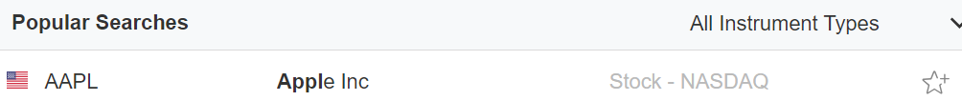
When a company becomes very popular, it can trade on more than one exchange in different countries as shown below, but it will trade on only one exchange in each country.
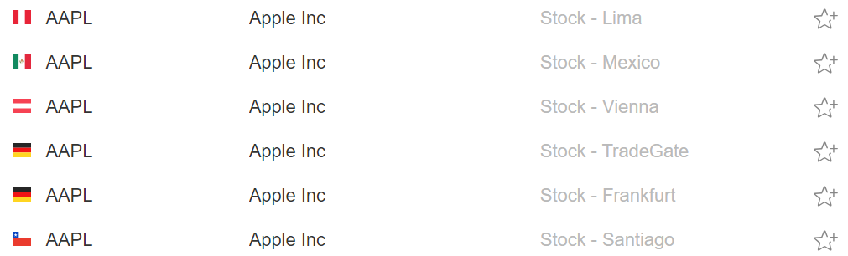
So, why are there many stock exchanges? Because each exchange has different purposes and different requirements for your company to be listed on. For example, NYSE requires your company to have at least X employees. The underwriting firm that does the IPO for your company decides which exchange your company’s stock can be listed on.
When your company is listed on an exchange, it should have a ticker. A ticker is like a label for your company on the stock market. For example, the ticker for Apple is AAPL as can be seen in the photos above.

Brokers
So, assume we now want to buy shares in a public company. We said that shares are listed on stock exchanges like NASDAQ or NYSE. These stock exchanges are actually physical places that exist in real life. For example, NASDAQ and NYSE buildings are shown below:
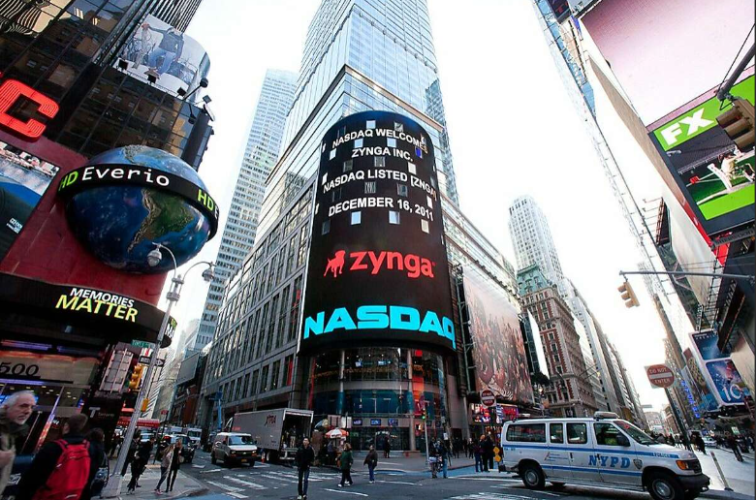
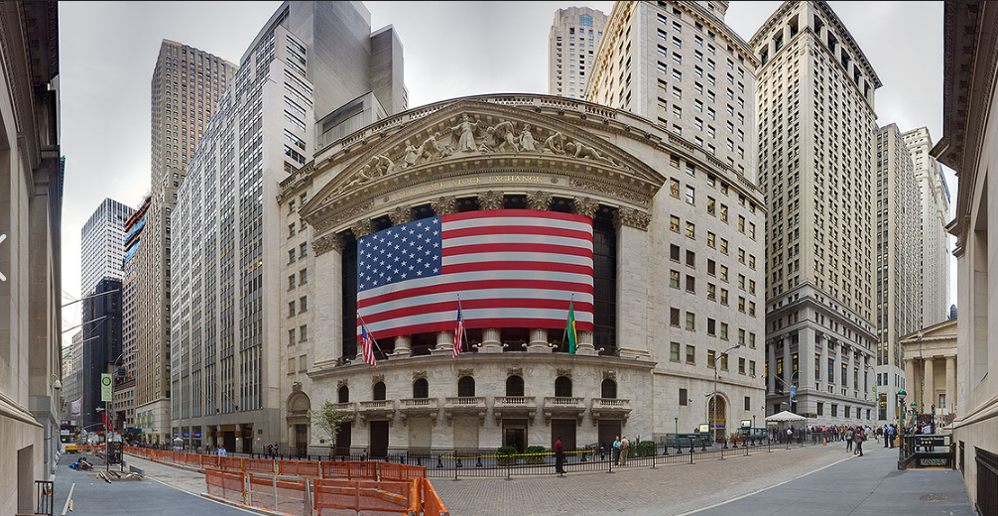
So, do we need to go by ourselves to NASDAQ or NYSE in the US to buy shares? No, and this is why we need a broker. A broker is a firm that facilitates the execution of a financial transaction for a fee. So, you own shares in Apple for example. You go to a brokerage firm and tell them that you would like to sell these shares at a certain price, and they take care of the rest (i.e. they go to NASDAQ and list your shares for the price you want). Now, someone wants to buy your shares. He goes to the brokerage firm, tell them that he wants to buy your shares, and they take care of the rest (i.e. they go to NASDAQ and buy him his shares). The diagram below illustrates the idea. The brokerage firm does this for a fee for sure. Thndr is an example of a brokerage firm in Egyptian stock market.
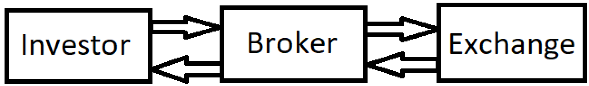
Notice that everything is now automated. That is, if you go to NYSE floor, you won’t find brokers that are shouting and screaming to buy/sell your shares anymore! Instead, you will find servers and computers on which shares are listed. So, why do we need brokers anymore? Why can’t we connect to NYSE directly and buy/sell shares? Because there are many other things/details that need to be done that a brokerage firm take care of for a fee. So, bottom line, you need a broker to be able to buy/sell stocks in public companies.

Orders, Prices, and Quotation
The stock in the US opens from 9:30 AM to 4:00 PM. Sometimes some trades can be done before or after this interval, but it is highly discouraged to trade outside this interval. So, we said that to go public, your company needs to undergo an IPO. So, assume your electric bike company called super bike went IPO. This is how the profile of your company initially looks like:
- Name: Super Bike.
- Ticker: SB.
- IPO Price: $28.57.
- Shares Outstanding: 7,000,000.
- Exchange: NASDAQ.
So, someone tells his broker that he wants to place an order whether to buy or sell shares. There are two types of orders:
- Limit order: you instruct your broker to buy or sell shares at a specific price or better. You are not guaranteed to have your order done because you might be demanding to buy shares at unavailable low price, or you might be demanding to sell shares at unwanted high price.
- Market order: you instruct your broker to buy or sell shares right away no matter the price.
At the stock exchange, orders are placed in a whatso called “order book”. An order book is divided into two columns, one for buyers and one for sellers. How are orders ordered in each column? For buyers, the buyer with the highest price is placed at the top of the list. For sellers, the seller with the lowest price is placed at the top of the list. So, shown below is an example of an order book (this book’s length extends to a very large depth, which is simply the total number of orders, I am just showing a small example). Each entry contains a price value and the number of shares to be bought/sold.
Buyers | Sellers
500 Shares - $26 | 300 Shares - $29
1000 Shares - $26.5 | 450 Shares - $29.7
750 Shares - $27 | 1000 Shares - $31

Usually, you as an investor won’t be interested in checking an order book. But what you will really be interested in is to know the bid and ask. The bid is the top entry in the buyers’ column, while the ask is the top entry in the sellers’ column. In other words, a bid is the highest price at which an investor wants to buy shares, while an ask is the lowest price at which an investor wants to sell shares. When you order a market order, it is executed on the bid or ask. You can also see the term last trade. This shows the last execution that was made.
An example is shown below for Facebook. The value 264.45 written in a large font at the top is the last trade. This is why this value keeps changing when you view any company’s stock because many trades are done, so the last trade is updated. You can also see the bid/ask at the bottom as 264.45 and 264.5.
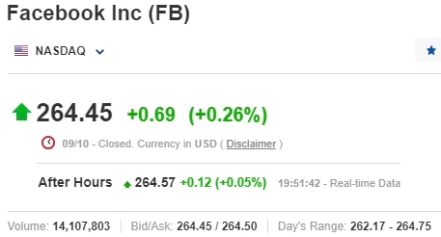
You can optionally watch the lecture from 8:08 to 24:43 for a good example.

Charts
In stocks, we see a lot of charts. Where do these charts come from? Every stock exchange, for example NASDAQ, disseminates all transactions that happen every day. A charting website takes this information and plot it in the form of a chart. So, what is a stock chart? A stock chart is a plot of the share price versus time. The share price is always the price of the last trade, while the time can be in minutes, days, weeks, months, years, etc. For example, the chart below is a daily chart for Facebook; it shows the price of the last trade done every day in 2020.
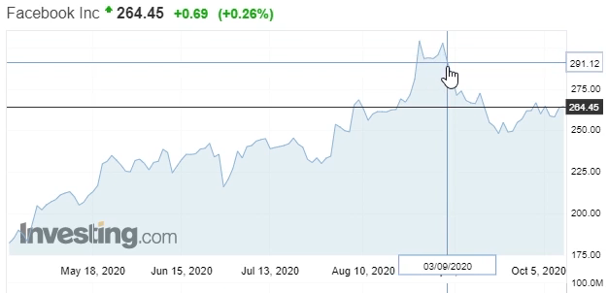
Which charting software to use? tradingview.com is the most popular one. Shown below is the view of a chart on the website:
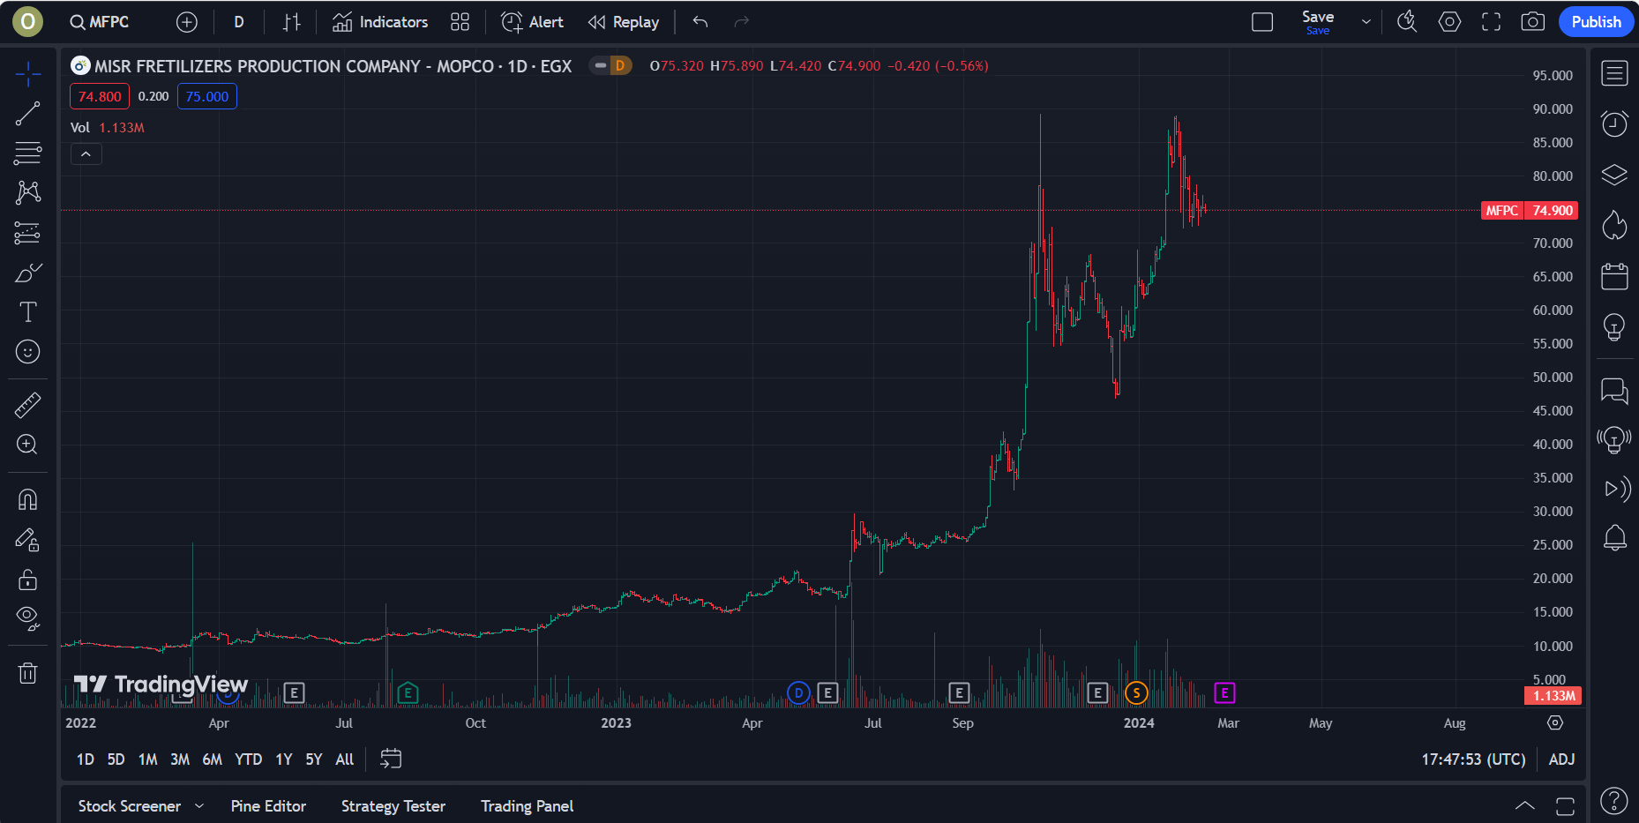
The toolbar at the top is shown below. The first button let’s you search for the company you want to see its chart. The ‘plus’ button allows you to compare with another company. The next button let’s you choose the time frame you want to look at. The next button let’s you choose the shape of the plot (e.g. candles, bars, lines, etc).
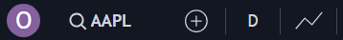
We always draw a “candlestick chart” instead of a “line chart”. Why? Check the line chart shown below.
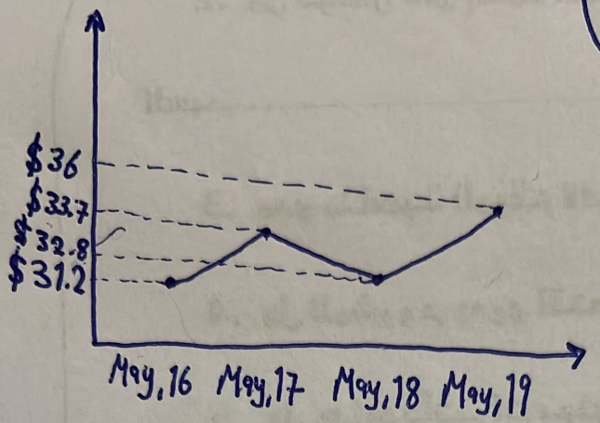
What information can we deduce from this chart?
Day | Last Trade
16th of May | $31.2
17th of May | $33.7
18th of May | $32.8
19th of May | $36

On the other hand, a candlestick chart would look as shown below.
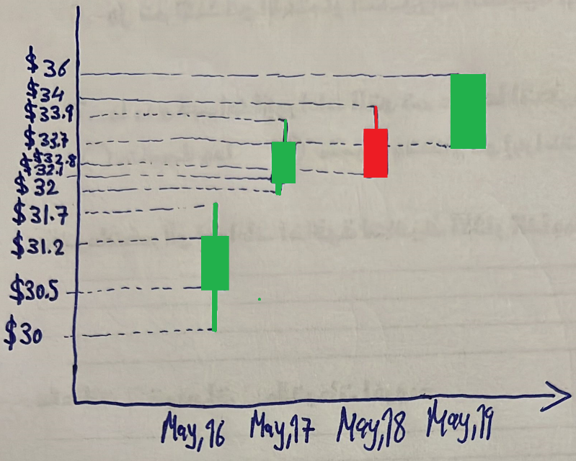
What extra information does a candlestick chart provide? A candlestick chart shows all of the following:
- Opening price.
- Closing price.
- Highest price.
- Lowest price.
- The candles color indicates whether the price went up or down in the specified range (e.g. day).
This is shown below:
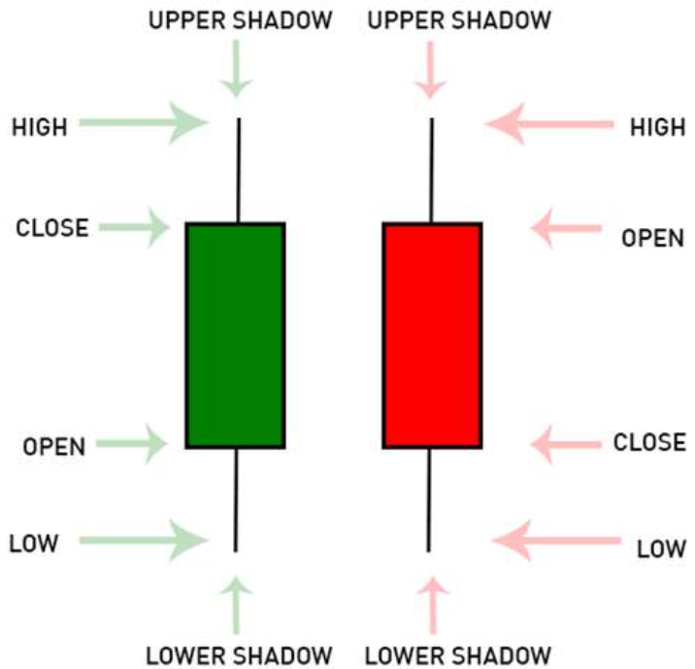
So, in the previous example, on the 16th of May, the candle is green, which means the closing price was higher than the opening price. Thus, the opening price is at the bottom of the candle, while the closing price is at the top of the candle. The opening price was $30.5. That is, the first transaction was done at $30.5. The lowest price was $30, the highest price was $31.7, and the closing price was $31.2. On the 18th of May, the candle is red, which indicates that the price went down. Notice that the lowest price is the same as the closing price, which was $32.8. On the 19th of May, the candle is green, which indicates that the price went up from $33.7 to $36. Notice also that the highest price was the same as the closing price, and the lowest price was the same as the opening price.
On the right, you can open the watchlist as shown below. A watchlist is a list where you can add companies of interest so that you can traverse between them faster.

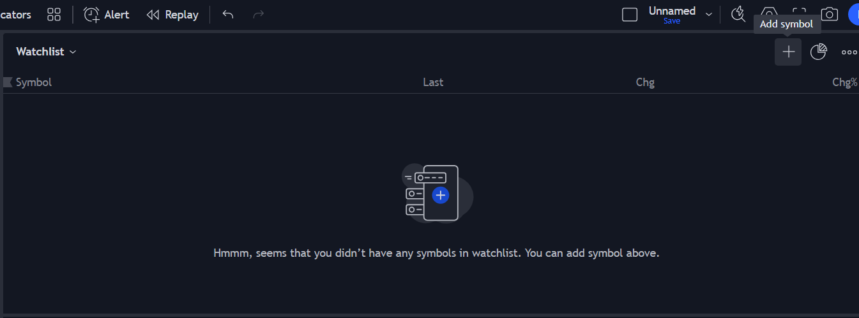

Volume
Volume is the quantity of shares traded in a specific period. The volume bars at the bottom of a chart shows the volume. For example, on the 13th of December 2023 in the chart below, the volume bar was high, which means there was many shares traded on this day. How many exactly? You can see it at the top left “Vol 4.814M”, which means 4.814 million shares were traded on that day.
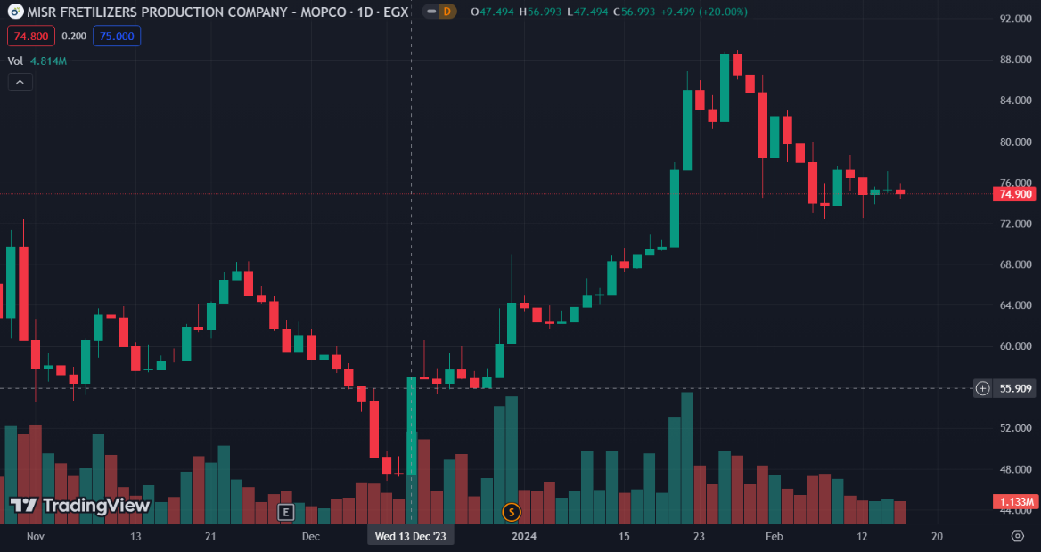
You can also see the opening, highest, lowest, and closing price as well as the change percentage on the top written as “O47.494 H56.993 L47.494 C56.993”, where the change percentage is calculated as follows:
$$Change \%=\frac{Closing Price-Opening Price}{Opening Price}×100\%$$
So, for the previous example:
$$\frac{56.993-47.494}{47.494}×100=+20\%$$

